ROSSMOYNE SENIOR HIGH SCHOOL


Yr11/12 Semester Two Examination, 2012

Question/Answer Booklet

MATHEMATICS 3A/3B

Section Two:

Calculator-assumed

Your name

Teacher’s name

Time allowed for this section
Reading time before commencing work: ten minutes
Working time for this section: one hundred minutes

Materials required/recommended for this section

To be provided by the supervisor
This Question/Answer Booklet
Formula Sheet (retained from Section One)

To be provided by the candidate
Standard items: pens, pencils, pencil sharpener, eraser, correction fluid/tape, ruler, highlighters

Special items: drawing instruments, templates, notes on two unfolded sheets of A4 paper, and up to three calculators satisfying the conditions set by the Curriculum Council for this examination.

Important note to candidates

No other items may be used in this section of the examination. It is your responsibility to ensure that you do not have any unauthorised notes or other items of a non-personal nature in the examination room. If you have any unauthorised material with you, hand it to the supervisor before reading any further.

Structure of this paper

Section | Number of questions available | Number of questions to be answered | Working time (minutes) | Marks available | Percentage of exam
Section One:  Calculator-free | 7 | 7 | 50 | 50 | 33
Section Two:  Calculator-assumed | 12 | 12 | 100 | 100 | 67
 |  |  | Total | 150 | 100

Instructions to candidates

- The rules for the conduct of Western Australian external examinations are detailed in the Year 12 Information Handbook 2012. Sitting this examination implies that you agree to abide by these rules.

- Write your answers in the spaces provided in this Question/Answer Booklet. Spare pages are included at the end of this booklet. They can be used for planning your responses and/or as additional space if required to continue an answer.
- Planning: If you use the spare pages for planning, indicate this clearly at the top of the page.
- Continuing an answer: If you need to use the space to continue an answer, indicate in the original answer space where the answer is continued, i.e. give the page number. Fill in the number of the question(s) that you are continuing to answer at the top of the page.

- Show all your working clearly. Your working should be in sufficient detail to allow your answers to be checked readily and for marks to be awarded for reasoning. Incorrect answers given without supporting reasoning cannot be allocated any marks. For any question or part question worth more than two marks, valid working or justification is required to receive full marks. If you repeat an answer to any question, ensure that you cancel the answer you do not wish to have marked.

- It is recommended that you do not use pencil, except in diagrams.

Section Two: Calculator-assumed (100 Marks)
This section has twelve (12) questions. Answer all questions. Write your answers in the spaces provided.

Working time for this section is 100 minutes.

Question 8 (3 marks)
A quantity is related to by the formula 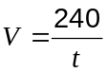.

Sketch the graph of on the axes below, labelling the exact coordinates of two points on the curve.

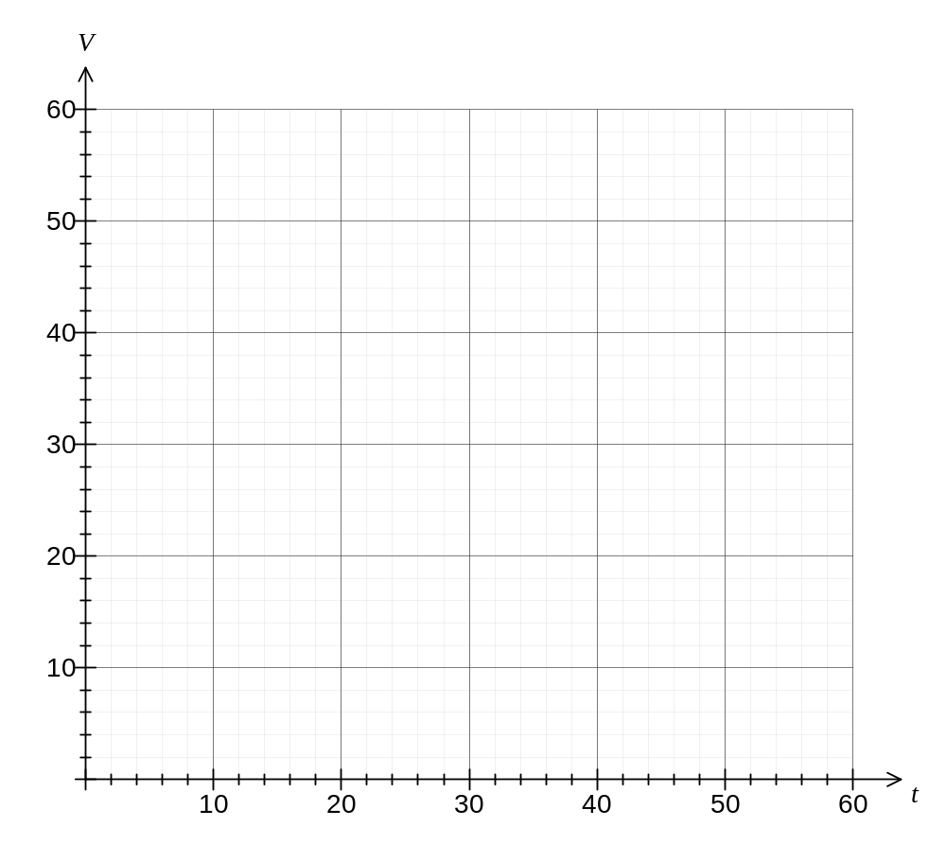

Question 9 (9 marks)
The price of unleaded fuel sold at 344 outlets was recorded daily for 30 days and this data is summarised in the following table.

Price of ULP (c/L) | Frequency
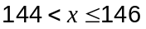 | 166
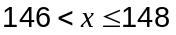 | 805
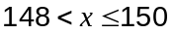 | 1348
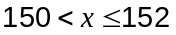 | 1947
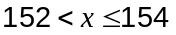 | 2339
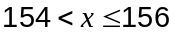 | 1485
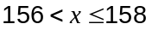 | 1371
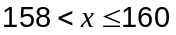 | 766
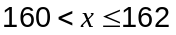 | 93

(a) Calculate the mean and standard deviation of these prices. (2 marks)

(b) On the axes below, draw a histogram to show the distribution of these prices. (3 marks)
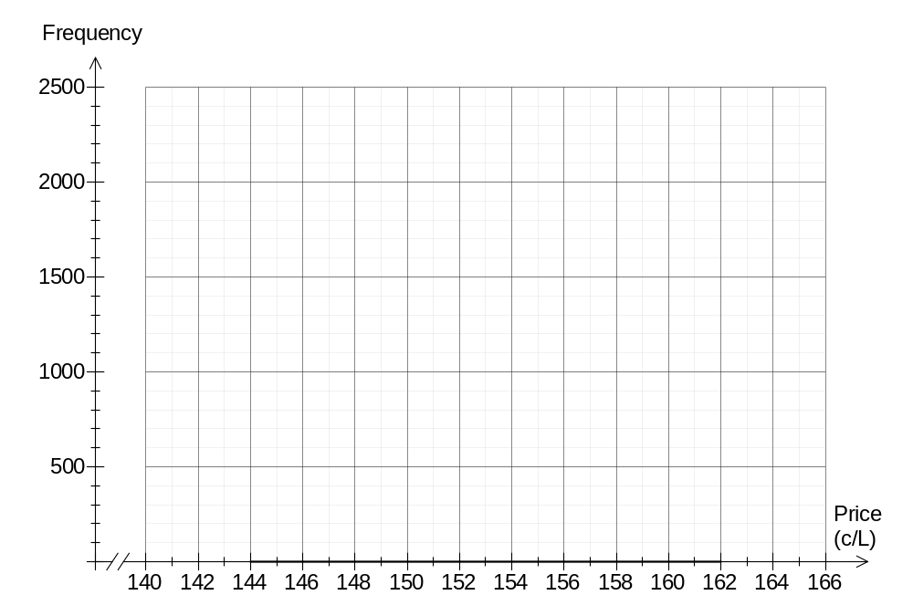

(c) What features of the histogram suggest that this data may be modelled by a normal distribution? (2 marks)

(d) Over the following 30 day period, prices were again recorded daily from all 344 outlets. The mean and standard deviation of the prices changed to 155.3 and 3.29 cents per litre respectively. Briefly compare the distribution of petrol prices in the first and second sets of observations. (2 marks)

Question 10 (8 marks)
A $5000 loan is to be repaid by fourteen monthly payments of $360 and a final, fifteenth, payment to bring the loan balance to zero. Interest, of 9% pa of the balance, is added at the end of each month before the payment is made.

The table below shows the amount in the loan account at the start and end of each month, together with the monthly interest payable.

Month | Amount at start of month | Interest | Repayment | Amount at end of month
 | 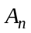 | 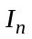 | 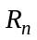 | 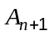
1 | 5000.00 | 37.50 | 360.00 | 4677.50
2 | 4677.50 | 35.08 | 360.00 | 4352.58
3 | 4352.58 | 32.64 | 360.00 | 4025.23
4 | 4025.23 | 30.19 | 360.00 | 3695.41
5 | 3695.41 | 27.72 | 360.00 | 3363.13
6 | 3363.13 | 25.22 | 360.00 | 3028.35
7 | 3028.35 | 22.71 | 360.00 | 2691.07
8 | 2691.07 | 20.18 | 360.00 | 2351.25
9 | 2351.25 | 17.63 | 360.00 | 2008.88
10 | 2008.88 | 15.07 | 360.00 | 1663.95
11 | 1663.95 | 12.48 | 360.00 | 1316.43
12 | 1316.43 | 9.87 | 360.00 | 966.30
13 | 966.30 | 7.25 | 360.00 | 613.55
14 | 613.55 | 4.60 | 360.00
15

(a) Write a recursive rule to determine the amount of the loan at the end of each month.
(2 marks)

(b) Complete the table for months 14 and 15, clearly showing the amount of the final repayment. (3 marks)

(c) How much interest will be paid over the life of this loan? (2 marks)

(d) Comment on the time taken to repay the loan if the repayment was changed to $36 per month. (1 mark)

Question 11 (8 marks)
(a) A student sat three tests, scoring 29 out of 45 in Test A, 28 out of 38 in test B and 45 out of 60 in Test C.

The following summary statistics were available for these three tests:

Test | Maximum | Mean | Standard Deviation
A | 45 | 24.8 | 8.2
B | 38 | 22.5 | 8.9
C | 60 | 36.2 | 12.8

Use standard scores (number of standard deviations from the mean) to compare the performance of the student in these three tests, explaining in which test the student performed the best. (4 marks)

(b) 50 tagged trout were released into a lake. Over weekly intervals, small samples of trout were caught from various locations around the lake, with the following results:

 | Number of trout in sample | Percentage of sample tagged
Week 1 | 40 | 5%
Week 2 | 20 | 10%
Week 3 | 50 | 4%

(i) Use the capture/recapture technique to estimate the number of trout in the lake.
(3 marks)

(ii) Give a possible reason why the percentage of the sample tagged in Week 2 was much higher than in the other two weeks. (1 mark)

Question 12 (6 marks)
A survey of car owners in a city determined that the annual distance they drove in 2010 was normally distributed with a mean of 12 600 km and a standard deviation of 3 750 km.

(a) If one of the car owners from the survey was randomly chosen, what is the probability that they drove between 10 000 km and 15 000 km? (2 marks)

(b) Find the minimum distance driven by at least 90% of drivers in the survey. (2 marks)

(c) If 2 400 car owners took part in the survey, estimate how many of them had driven more than 20 000 km. (2 marks)
Question 13 (8 marks)
A triangle ABC has sides AB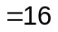cm and BC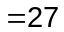cm and angle ABC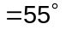.

(a) Calculate the length of AC. (3 marks)

(b) P is a point on the side BC so that the distance AP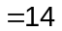cm. Find the largest possible area of triangle APC. (5 marks)

Question 14 (14 marks)
The methane concentration in parts per billion (ppb) measured quarterly at a weather station over a period of five years from 1991 to 1995 is shown in the graph and table below.

Time period () | Year | Month | Methane concentration (ppb) | 4-Point Centred Moving Average () | Residual
1 | 1991 | Mar | 1654 | - | -
2 | 1991 | Jun | 1676 | - | -
3 | 1991 | Sep | 1689 | 1677.4 | 11.6
4 | 1991 | Dec | 1681 | 1681.5 | -0.5
5 | 1992 | Mar | 1673 | A | B
6 | 1992 | Jun | 1690 | 1687.5 | 2.5
7 | 1992 | Sep | 1703 | 1688.4 | 14.6
8 | 1992 | Dec | 1687 | 1688.8 | -1.8
9 | 1993 | Mar | 1674 | 1689.0 | -15
10 | 1993 | Jun | 1692 | 1689.4 | 2.6
11 | 1993 | Sep | 1703 | 1690.1 | 12.9
12 | 1993 | Dec | 1690 | 1691.3 | -1.3
13 | 1994 | Mar | 1677 | 1692.6 | -15.6
14 | 1994 | Jun | 1698 | 1694.1 | 3.9
15 | 1994 | Sep | 1708 | 1696.0 | 12
16 | 1994 | Dec | 1697 | 1697.5 | -0.5
17 | 1995 | Mar | 1685 | 1698.9 | -13.9
18 | 1995 | Jun | 1702 | 1700.5 | 1.5
19 | 1995 | Sep | C | - | -
20 | 1995 | Dec | 1703 | - | -

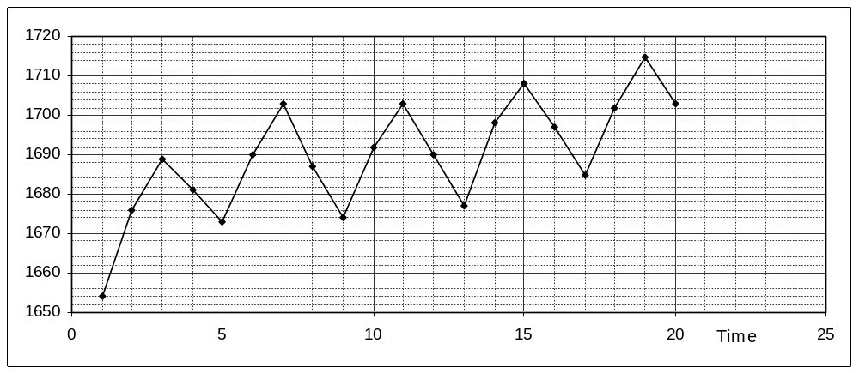

(a) Explain why calculating a centred 4-point moving average is an appropriate way to smooth this data. (1 mark)

(b) Determine the values of A, B and C in the table above. (3 marks)

(c) Calculate the linear regression model for the smoothed data () against time () and write down the value of the correlation coefficient for this relationship. (3 marks)

(d) Add your linear model from (c) to the graph. (2 marks)

(e) Calculate the seasonal component for the September quarter and explain what this value means in the context of this question. (2 marks)

(f) Predict the methane concentration for September 1996 and comment on how reliable this prediction is. (3 marks)

Question 15 (10 marks)
A function has equation 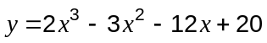.

(a) Using calculus techniques, determine the coordinates of both stationary points of the function. (3 marks)

(b) Sketch the graph of the function over the domain 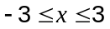, labelling all intercepts and stationary points. (4 marks)
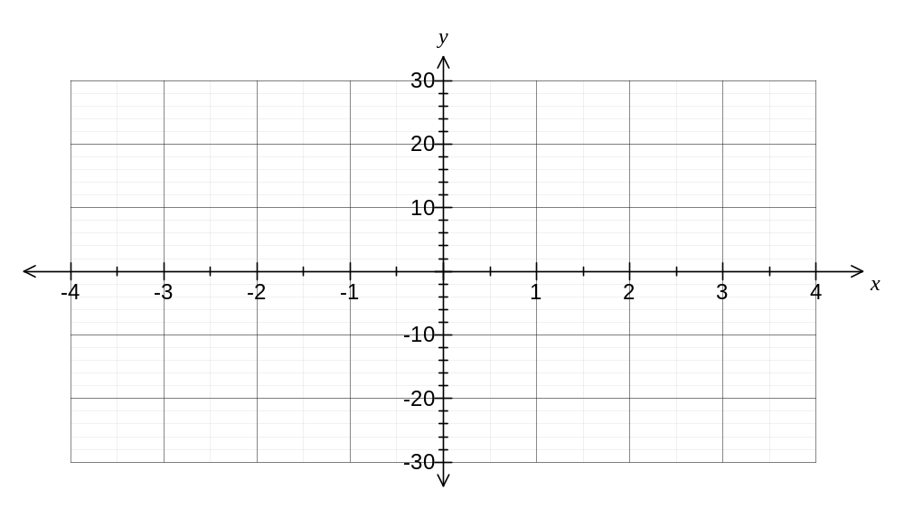

(c) Determine the coordinates of the point on the curve, other than the -intercept, where the gradient is equal to that of the tangent at the -intercept. (3 marks)

Question 16 (7 marks)
An employer is considering two pay schemes for new employees:
Scheme A
For the first month, a new employee is paid $750. In subsequent months, their pay is increased so that it is $40 more than the previous month.

Scheme B
For the first month, a new employee is paid $750. In subsequent months, their pay is increased so that it is 5% more than the previous month.

(a) Write a recursive rule for 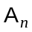, the payment made in month to an employee using Scheme A and another recursive rule for 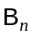, the payment made in month to an employee using Scheme B. (3 marks)

(b) In which month does the payment using Scheme B first exceed that using Scheme A, and by how much? (2 marks)

(c) If an employee only worked for 6 months, which pay scheme should they choose in order to gain the most pay? Justify your answer. (2 marks)

Question 17 (10 marks)
The graphs of the functions  and 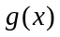 are shown below.
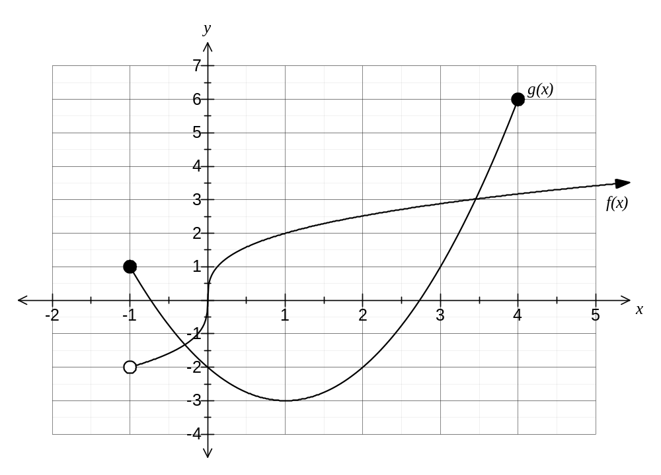

(a) State the domain of . (1 mark)

(b) State the range of . (1 mark)

(c) Which function(s), if any, have a point of inflection? (1 mark)

(d) Describe how the graph of 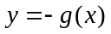 may be obtained from the graph of 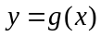 and hence state the coordinates of the turning point of the graph. (2 marks)

(e) Describe how the graph of 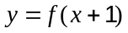 may be obtained from the graph of 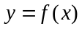 and hence state the coordinates of the root of the graph. (2 marks)

(f) State the equation of the line of symmetry of the graph of . (1 mark)

(g) State the solution(s) to the equation 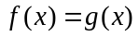. (2 marks)

Question 18 (10 marks)
A gardener makes their own blend of lawn fertiliser by mixing together bags of Go-Green and bags of Lush-Leaves. Each bag of Go-Green contains 40 grams of nitrogen and 20 grams of phosphorus. Each bag of Lush-Leaves contains 160 grams of nitrogen and 30 grams of phosphorus.

The blend must contain at least 800 grams of nitrogen, at least 300 grams of phosphorus, and must use at least twice as many bags of Go-Green as Lush-Leaves.

(a) Write three inequalities, other than 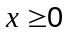 and 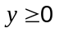, which satisfy the above constraints.
(3 marks)

(b) Draw the three inequalities from (a) on the graph and shade the region that satisfies these inequalities. (4 marks)
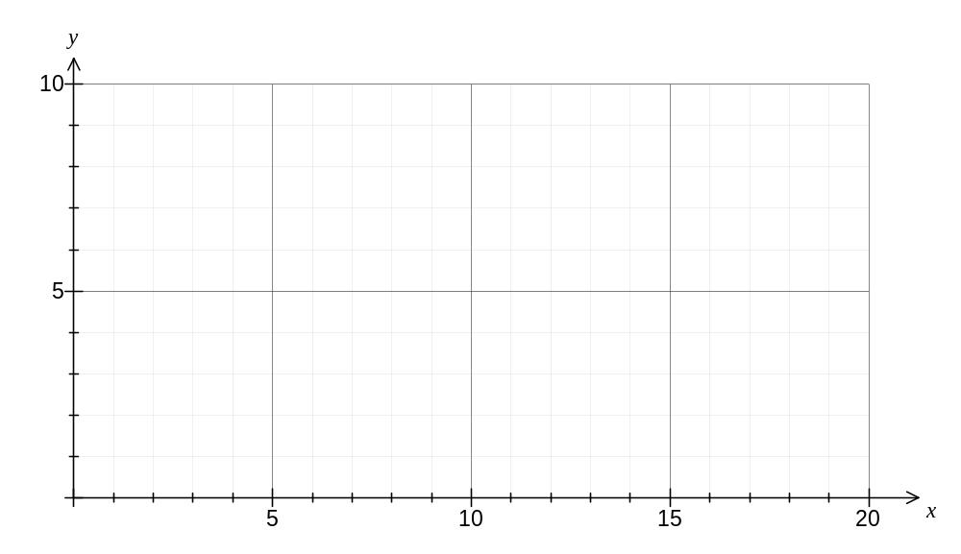
(c) If one bag of Go-Green costs $3 and one bag of Lush-Leaves costs $8, how many of each should the gardener use to make their blend for the cheapest possible cost, and what is this cost? (3 marks)

Question 19 (7 marks)
A pyramid has a square base of side and perpendicular height and is such that the sum of the side length, , and height, , is 15 cm. | 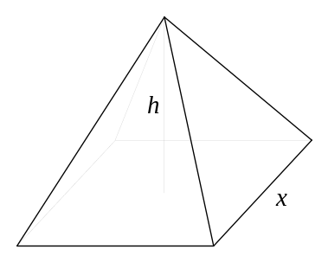

(a) Show that the volume, , of the pyramid is given by 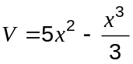 cm³. (3 marks)

(b) Using calculus techniques, find the value of that will maximise the volume of the pyramid, and state this maximum volume. (4 marks)

Additional working space

Question number: _________

Additional working space

Question number: _________

This examination paper may be freely copied, or communicated on an intranet, for non-commercial purposes within educational institutes that have purchased the paper from WA Examination Papers provided that WA Examination Papers is acknowledged as the copyright owner. Teachers within purchasing schools may change the paper provided that WA Examination Paper's moral rights are not infringed.

Copying or communication for any other purposes can only be done within the terms of the Copyright Act or with prior written permission of WA Examination papers.

Published by WA Examination Papers
PO Box 445 Claremont WA 6910

